**WebProgramming1 report**

S00196433 Zoe Conroy

1. Incorporate the initial design proposal as the first section of this report

**Project description**

A)What is the idea behind the website?

The idea is to search tv shows which will allows user to access chosen shows details including episodes which can also be selected for more information both can be bookmarked.

B) What are the main features of your website?

* Search TV shows
* List all possible results.
* Tv shows details include year started, status, language, genres, plot with list of episodes and episode search bar.
* Episodes details include episode name, airdate, runtime and plot.
* Bookmark TV shows and episode

C) What users might find this site useful, interesting, fun?

Bookmarking shows and episode as it could be used to keep track of last watched or favourite episode of multiple shows.

**2.User Interface (UI) design**

a) Does the UI meet the requirements?

Yes, I believe it fulfil the UI requirements with its simple layout.

b) Are page elements (menu, text boxes, buttons, etc.) placed in a user-friendly manner? - Is it obvious to the user how to use your website, where to click to access the main features of your site, how to complete forms, etc.?

Yes, there is a very limited number of buttons all with clear functions.

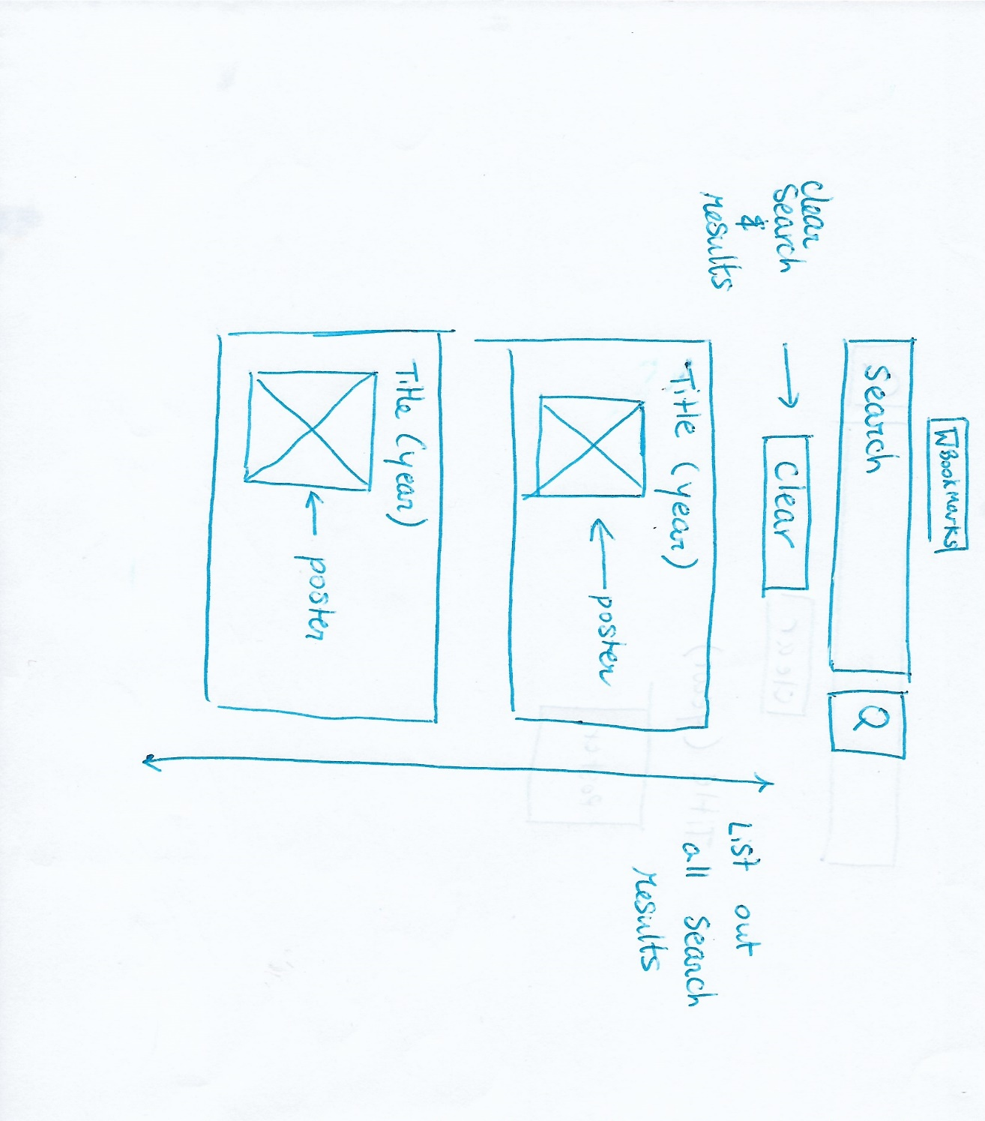

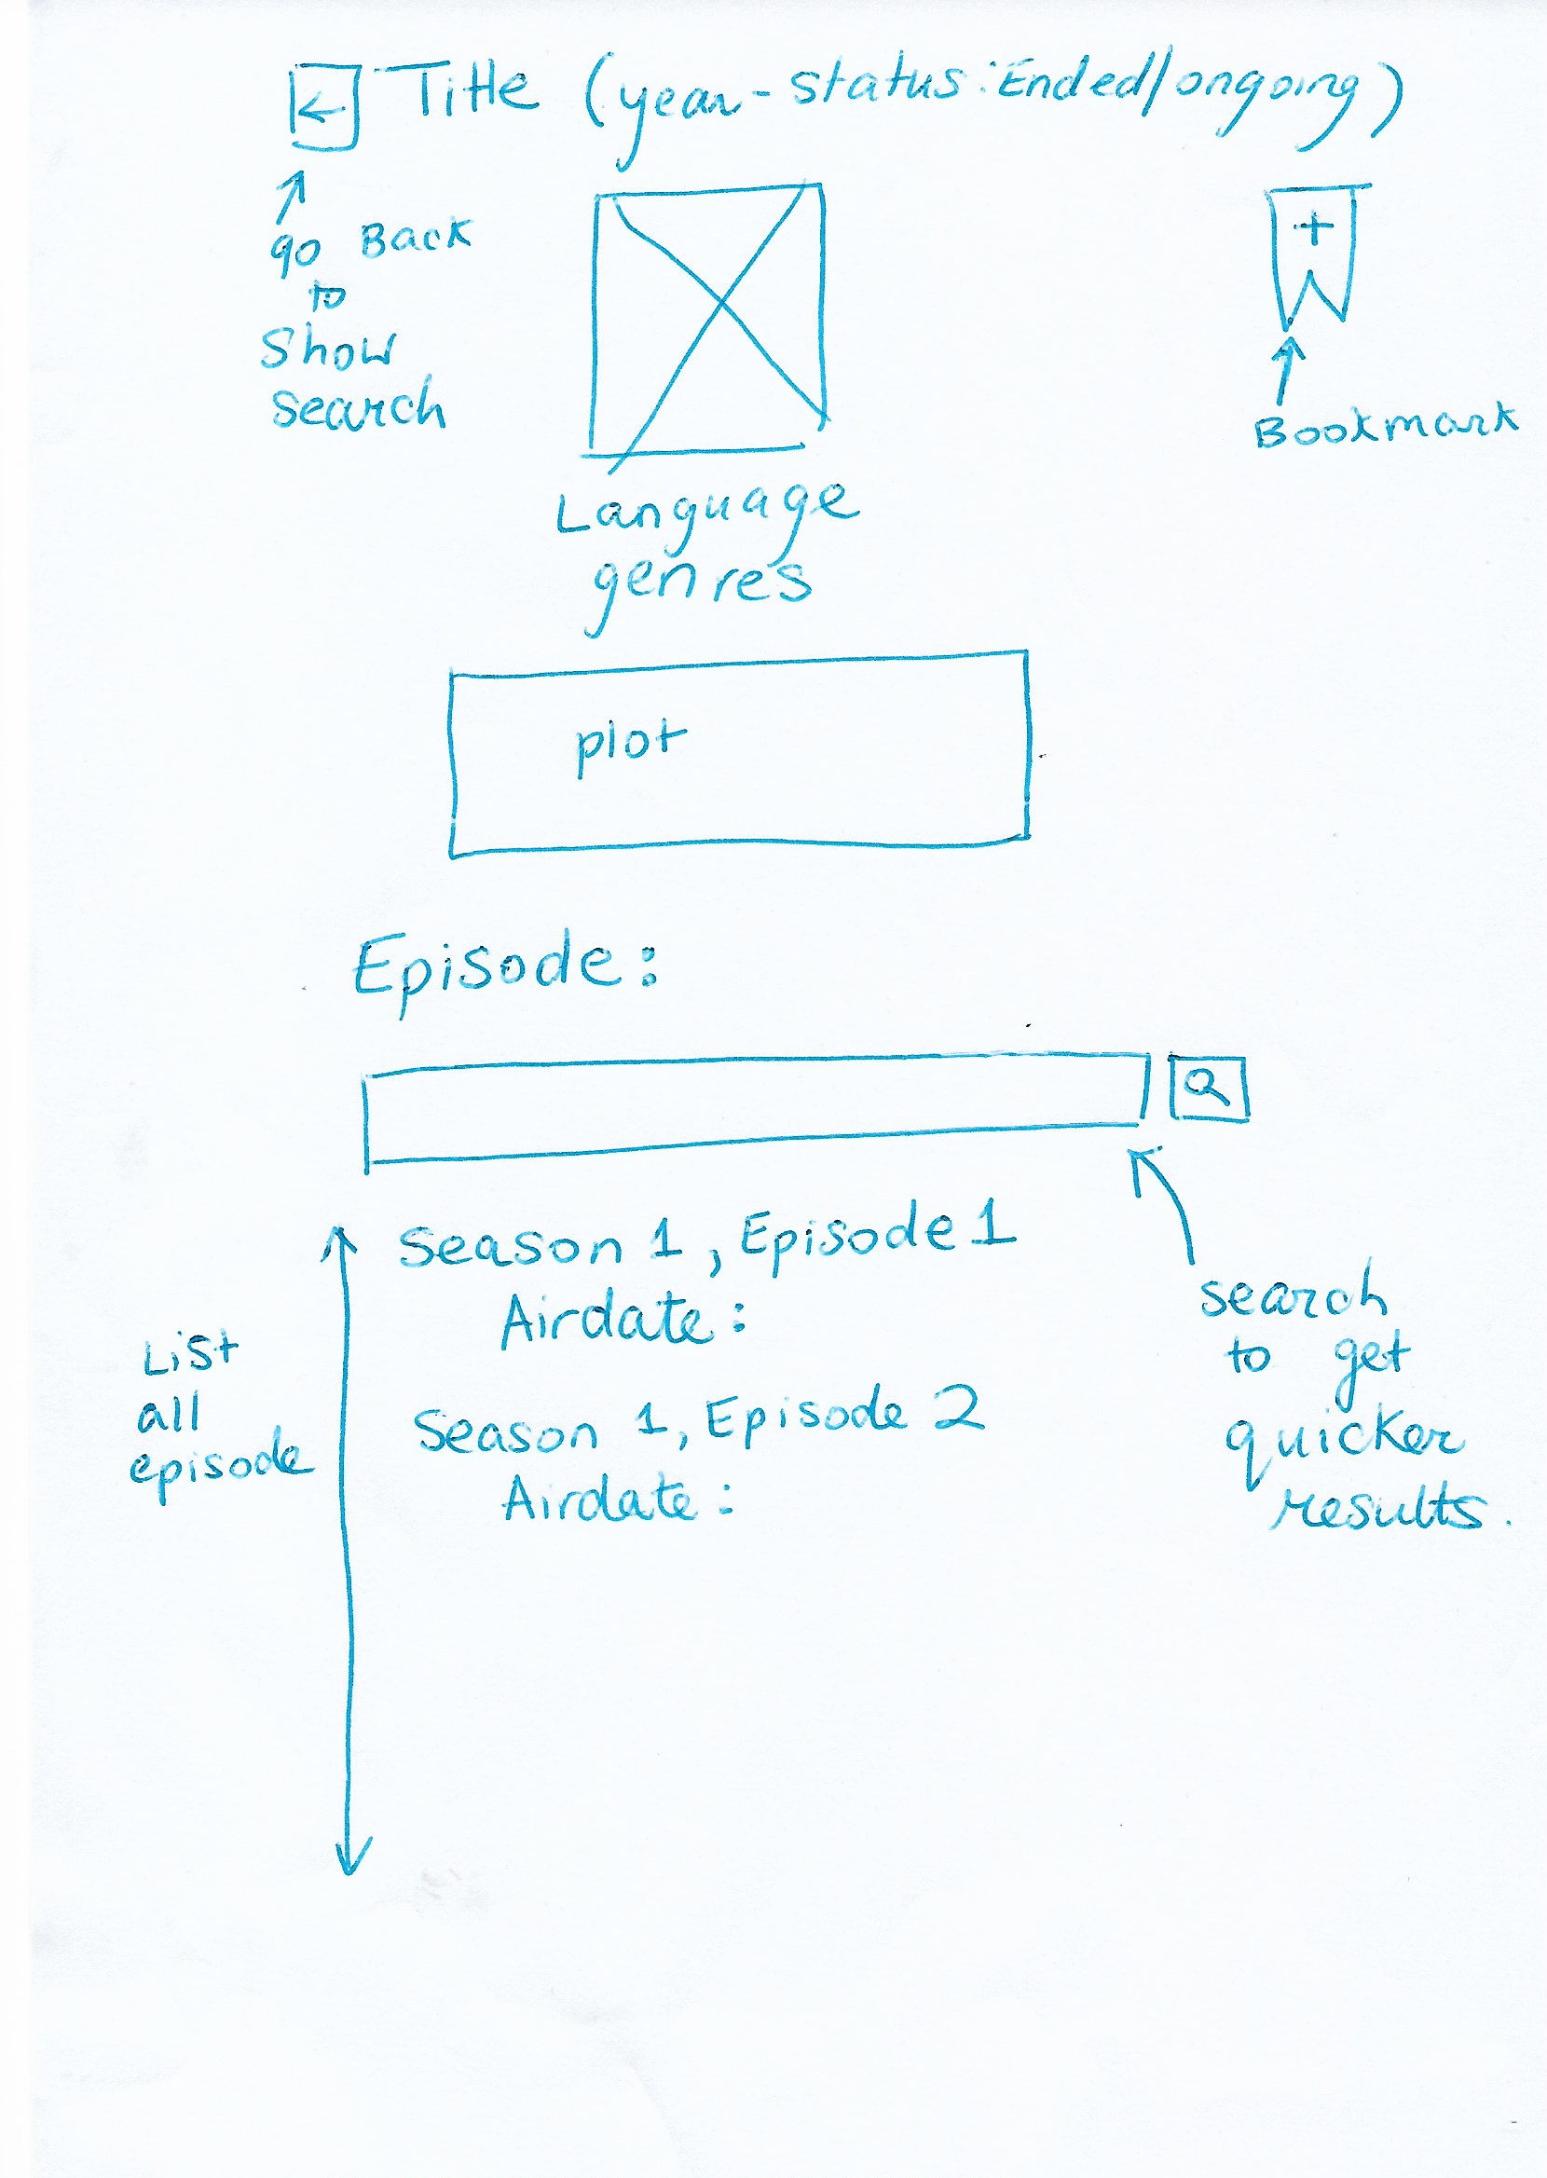

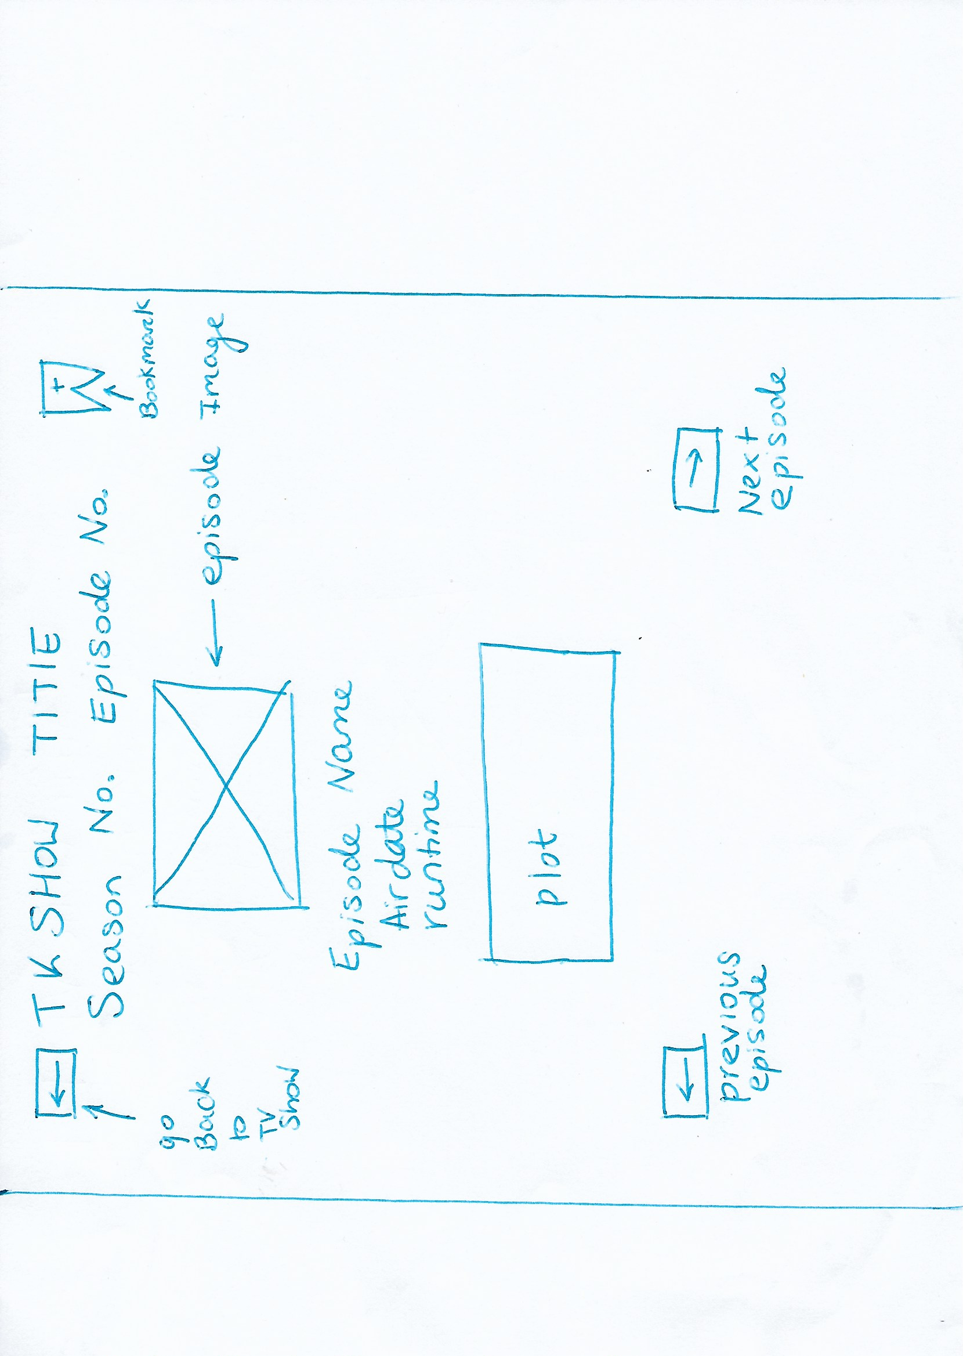

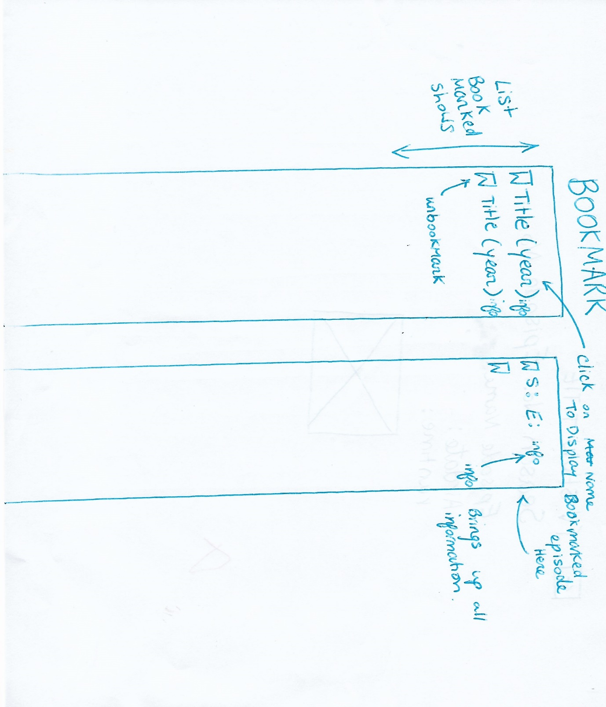

1. **Architecture Diagram**

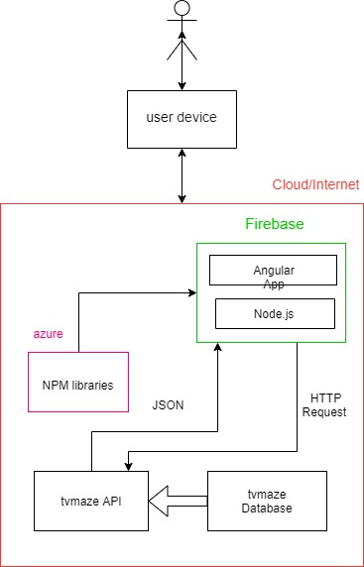

1. Create a component diagram. Briefly outline their function

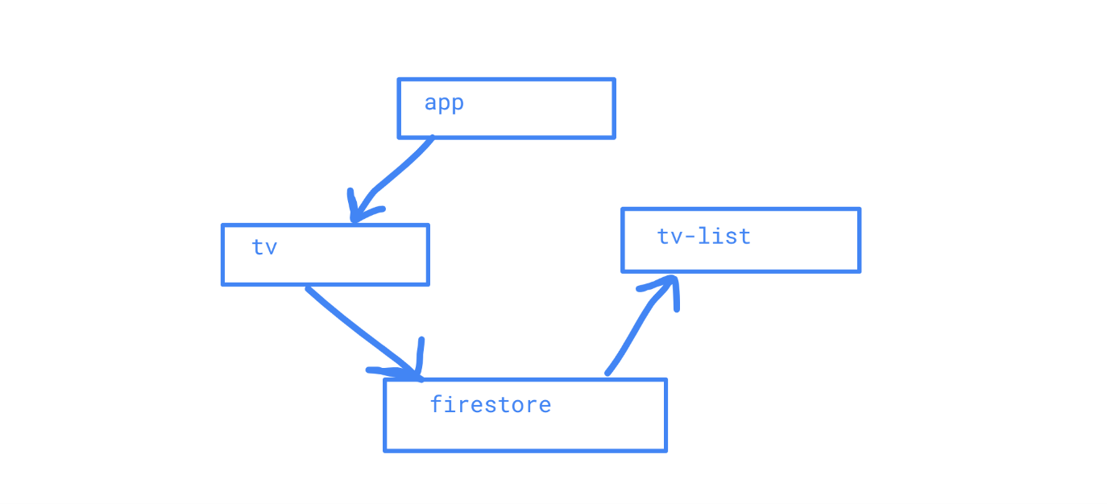

TV-details

App links to tv which connects to the tvmaze API which you can save to firestore then tv-list called what is saved in firestore

1. Outline how the finished application differs from the original proposal and why.

* It does not have a TV maze search by episode API as due lacking experience to know how to manage two API.
* It is all on 1 page due to time restrain not allowing to put in routes.

1. Include screenshots of the main elements of the Application

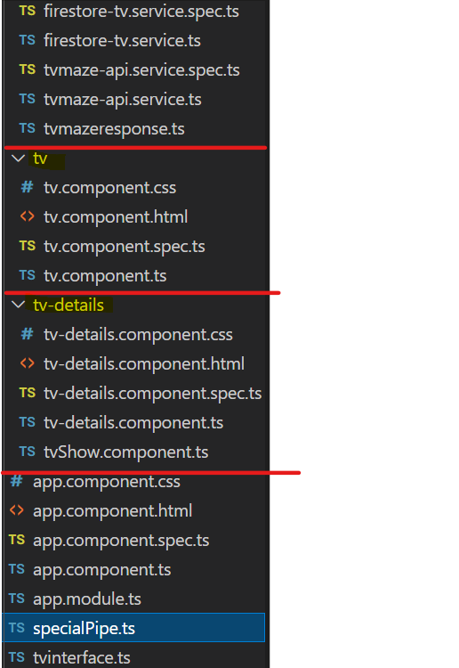

1. List the main CSS classes used, where they were used and what they were used for

Bootstrap styled most of the project with

**tv.component.css:**

To style search, buttons, background colour, poster, and display

And

**tv-details.component.css:**

to style the delete button.

1. Screenshots of the App

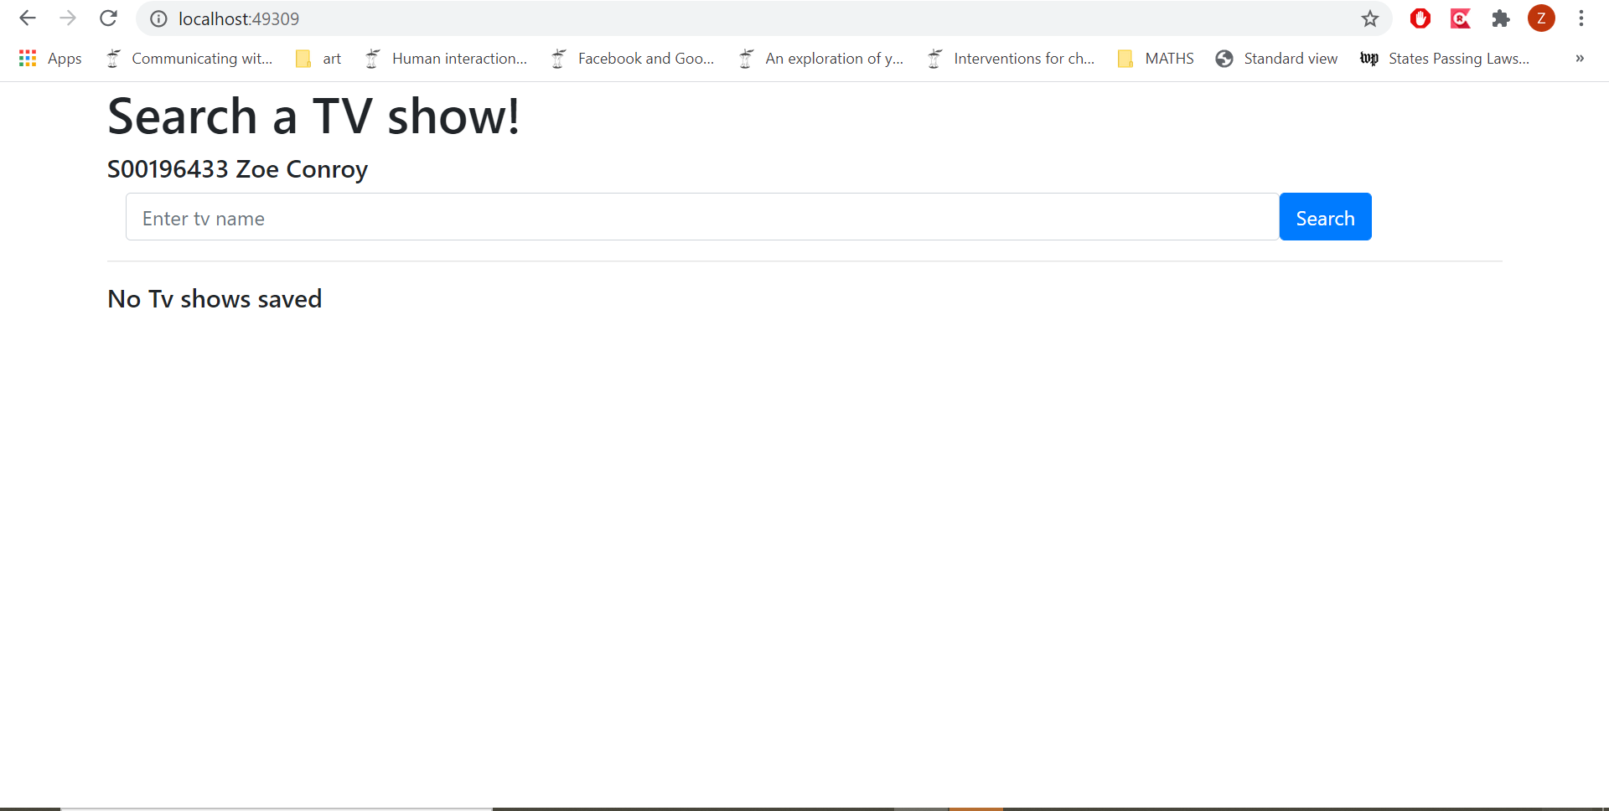



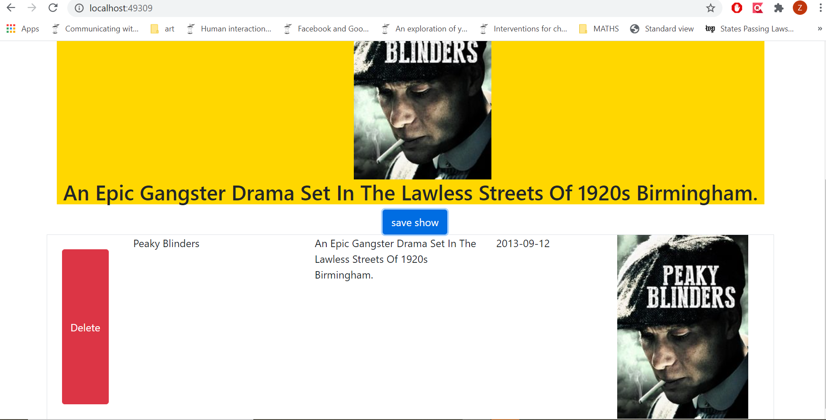

1. A **200 word reflection (**more is fine too**)** on this project. Outline how the project has gone for you, detail areas you struggled with and areas you feel you have learned a lot in. Your opinion matters here.

I feel the project went well for me as there was a lot I was not familiar with and struggled with such things as getting the details I tried to save from the TVmaze API to save into firestore. I also struggled to connect the TV components to the tv-details components, as well as struggling to get the data from firestore which I assumed would just require editing carsales-nosql task, but I found it took more work such as a new interface. The delete button was also more challenging than I anticipated as once again I assumed just editing carsales-nosq but, in fact required me to make edits based off my own research. Doing my own research made me become more familiar with different aspects of angular but caused for time to be spent inefficient as trying a lot of different ways to solve problems in the code with a lot leading too dead ends and searches returning up nothing. I also did not get to complete all the plans I had for my project Proposal as I underestimated the time it would take to get the basic working such as the API and firestore, but I feel if I had more time with the experience I got from this part of the project I could adapted it to the other parts as I have learned a lot about API, displaying data and firestore and interacting with data from firestore.

1. Evaluate your work using the marking scheme provided (In Marking Scheme Spreadsheet). Give yourself a mark.

